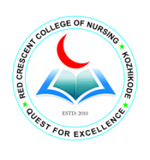
REDCRESCENT COLLEGE OF NURSING
FEROKE, KOZHIKODE
Students Union

Executives 2023
Sl No | Name of the Post | Name of the Candidate
1 | Chairperson | Mr. Delse M Joseph
2 | Vice- Chairperson(G) | Ms. Myza Mahmood
3 | Vice- Chairperson(W) | Ms. Anagha K
4 | Secretary | Mr. Muneersha
5 | Joint Secretary | MS. Haifa Afrin P
6 | Secretary Arts | Mrs. Jisna Shinoj
7 | College Magazine | Ms.Anjana Reji
8 | Sports secretary | Ms.Sneha EK
9 | UUC | Ms.Kapilan M Moosad
10 | Class Rep | Ms. Ganza EK
11 | Advisor | Mrs. Prajitha VM, Assistant Professor

